

|  |  |  |  |  |  |  |  |  |
| --- | --- | --- | --- | --- | --- | --- | --- | --- |
|  | | | | | | | | |
|  | | DB LAB 07 Exercise 2 | | | | |  | |
|  |  | | | | | | |  |
|  | | | |  |  | | | |
|  | | | | Basil Ali Khan(20K-0477) |  | | | |
|  | | | | 16th October 2022—Database and Management System Lab—Sir Ahmed Budhi |  | | | |
|  | | |  | | |  | | |

Exercise#02:

Task#01:

CREATE OR REPLACE VIEW Acc_View AS

SELECT e.* , d.DEPARTMENT_NAME

FROM HR.EMPLOYEES e JOIN HR.DEPARTMENTS d ON e.DEPARTMENT_ID = d.DEPARTMENT_ID

where d.DEPARTMENT_NAME = 'Accounting';

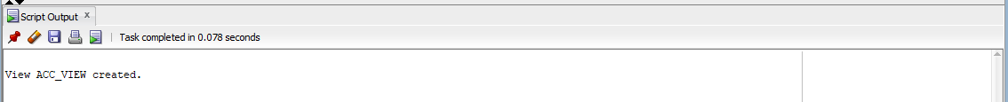

SELECT *

FROM Acc_View;

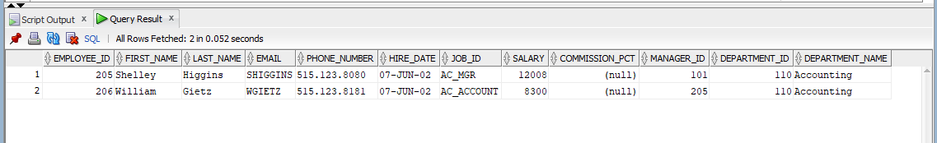

Task#02:

set SERVEROUTPUT on;

DECLARE

CURSOR C1 IS

SELECT * FROM HR.EMPLOYEES WHERE SALARY>2000;

BEGIN

FOR i IN C1 LOOP

DBMS_OUTPUT.PUT_LINE('Id = ' || i.employee_id || ', First Name = '|| i.first_name || ',Salary = '|| i.salary );

END LOOP;

END;

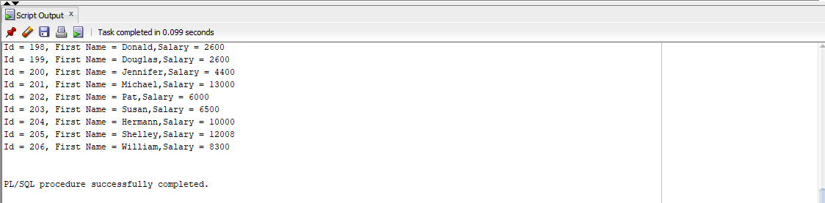

Task#03:

set SERVEROUTPUT on;

DECLARE

CURSOR C2 IS

SELECT * FROM HR.EMPLOYEES order by SALARY asc;

BEGIN

FOR i IN C2 LOOP

DBMS_OUTPUT.PUT_LINE('Id =' || i.employee_id || ',First Name = '|| i.first_name || ',Salary = '|| i.salary );

exit when C2%rowcount=10;

END LOOP;

END;

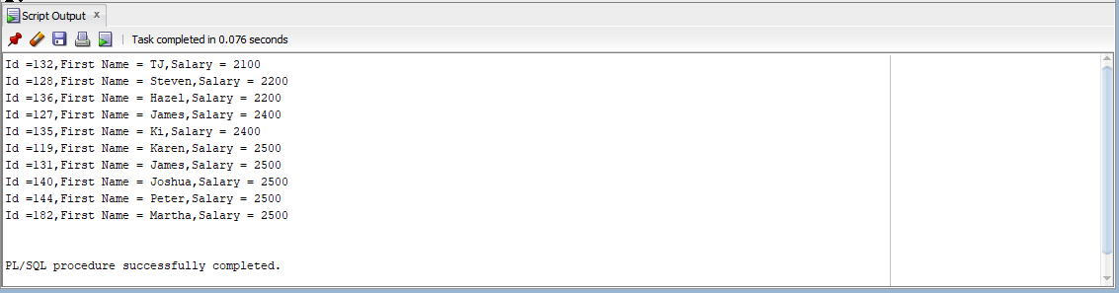

Task#04:

create or replace procedure my_func

is

x integer;

y integer;

res integer;

begin

x:=10;

y:=04;

res:=0;

res:= x + y;

dbms_output.put_line('Sum of 2 numbers is: ' ||res);

end;

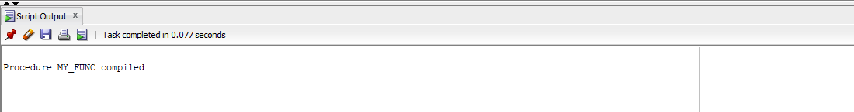

Exec my_func;

